SE2 Tutorial 8 Homework- Nguyen Duy Thai Son- 1701040191

Activity 1:

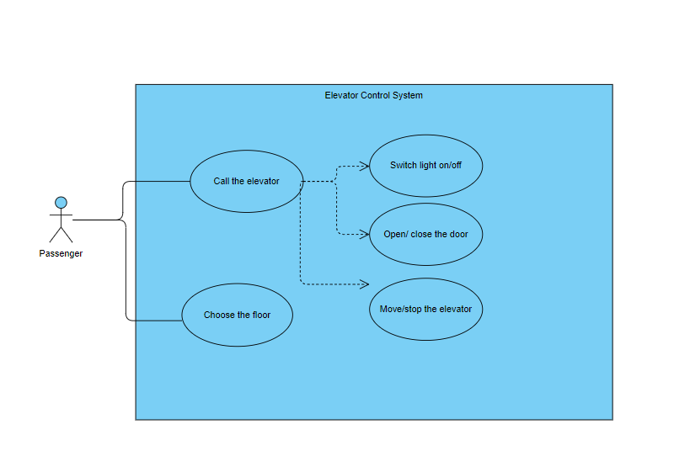

Activity 2:

